EOQ1 | 700
EOQ2 | 715 1000
EOQ3 | 719 2000
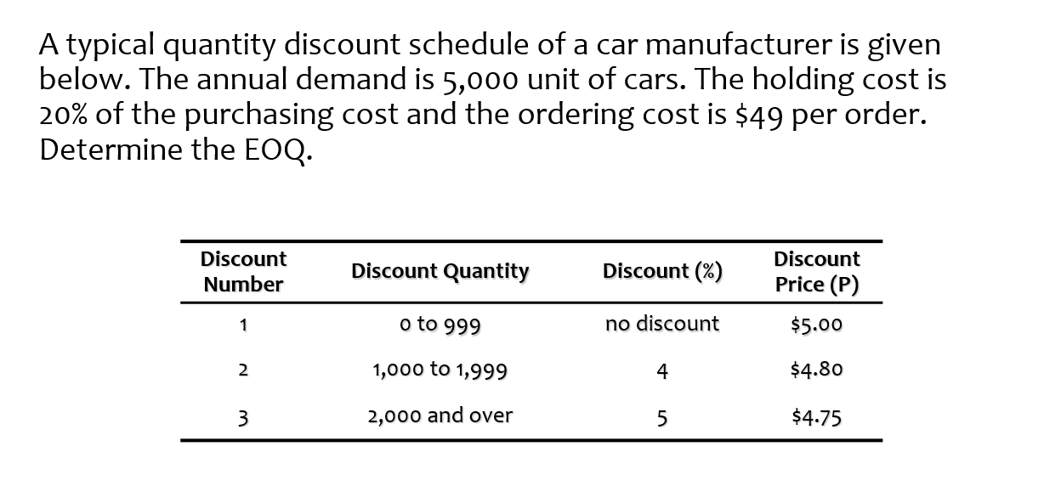
Annual Demand, D = 5000
Ordering Cost, S =49
Holding Cost, H =.2*P
Discount  Number | Unit cost  P | Order Quantity  EOQ | Annual Purchasing Cost  PD | Annual Ordering Cost  DS/EOQ | Annual Holding Cost  (EOQ*H/2) | Total
1 | 5 | 700 | =5000*5  =25000 | =5000*49/700  =350 | =(700*1)/2  =350 | =25700
2 | 4.8 | 1000 | =5000*4.8  =24000 | =5000*49/1000  =245 | =(1000*.96)/2  =480 | =24725
3 | 4.75 | 2000 | =5000*4.75  =23750 | =5000*49/2000  =122.5 | =(2000*.95)/2  =950 | =24822.5

